How to Ship and Invoice a Dropship order in VendorNet

- Log into VendorNet

- Be sure you have printed any new Dropship orders that may have imported into VendorNet prior to the last time you may have logged on.

- Click on Ship and Invoice from the Left Hand Menu

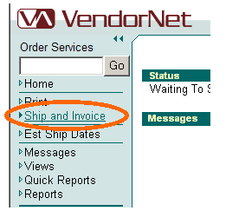

- This will give you a screen that looks like this. From here click on Start Shipping in the upper right hand corner of your Screen
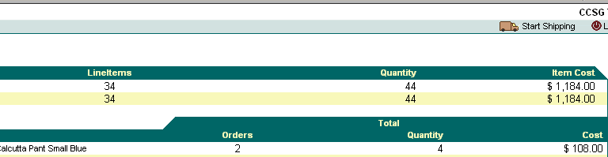

- This will open a screen showing you all your open orders. Be sure to fill out the invoice and tracking information for each of the orders you need to ship and invoice. If you have additional tracking numbers, please click “Add Addtl Package” as needed. Then click Process Shipments.
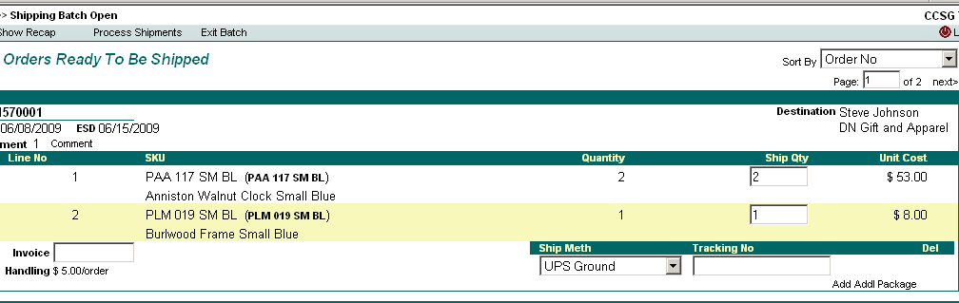

- You will then see the “Shipping Batch Recap” as pictured below. Please verify all information displayed.
  - To edit any information that you’ve entered, click “Edit Details”. You will be taken back to the “Printed orders ready to be shipped” screen where you may change as needed. Click on “Process Shipments” to return to the “Shipping Batch Recap”;
  - If the Cost is incorrect, contact your buyer or planner before you Update as they will need to make the necessary changes before you complete the process;
  - If/When all information displayed is correct, click on “Update Shipments”
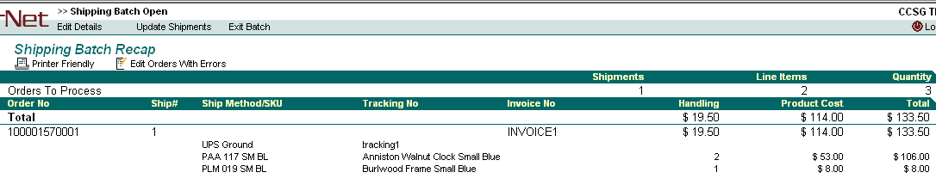

- After clicking on “Update Shipments”, you will then get a small dialog box confirming that you want to process this batch. Click “OK” if you want to process the batch.
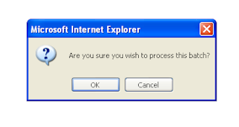

8. Your final screen should be as seen below:

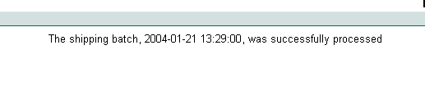

If you have any questions/concerns regarding this process, Please contact the Vendor Technologies Group at VTG@cornerstonebrands.com.

