How to print a new Stock PO in VendorNet.

This document will provide you all the tools necessary to understand how to print new Stock Purchase Orders (a.k.a. Stock PO’s) in VendorNet. There are many screen shots in this document. To help you quickly identify important places on the screen we have added dashed oval (like this, ). If at the end of using this document you are still having trouble printing or are receiving errors during the print process contact the VendorNet Technogies Group email address is vtg@cornerstonebrands.com.

**Important Note**
Printing out new orders from VendorNet is a key function of the VendorNet process. Upon receipt of a new order notification, be sure to print your new order as soon as possible. Your ability to acknowledge orders, and ultimately create shipping labels and ASN information begins in the Printing stage.

Steps to Follow

- Log on to VendorNet

- Click on the word “Print” on the left hand side of the screen underneath the “Order Services” box (make sure you have “Stock PO” selected if the option is available in the lower left hand side).

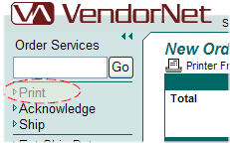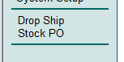

- This will bring you too a screen like this.

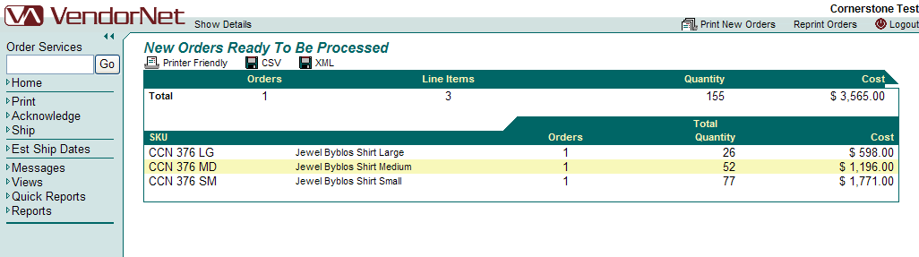

- Click on Print New Orders in the upper right had side of the screen.

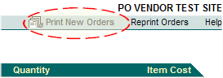

- On the new screen the last step brings up click the “Click Here” to start printing.

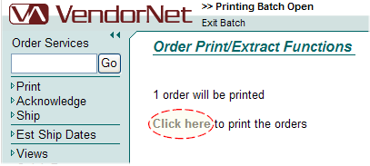

- Next you should see you’re a new browser window open up.

- Print and/or Save your order as needed. Exit the browser window.

- You will be returned to the Home/Welcome screen once it’s finished processing.

Please contact VTG@cornerstonebrands.com if you require further assistance.

