How to print a Dropship order in VendorNet:

- Log into VendorNet.

- Now Click on Print from the left-hand menu (make sure you have “drop ship” selected if the option is available on the lower left hand side).

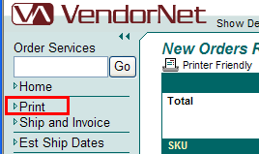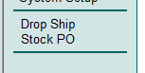

- Click on Print New Orders in the upper right hand side of the screen.

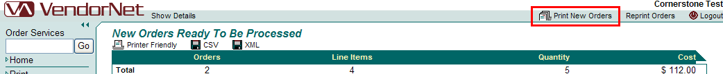

- This will change the screen to show the graphic below. Click on the “Click Here”

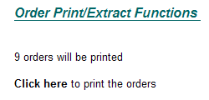

- A new browser window will open displaying the packslip with information. You may print or save as necessary.

Please contact VTG@cornerstonebrands.com if you require further assistance.

