How to Acknowledge a Stock PO order in VendorNet

- Log into VendorNet

- Be sure you have printed any new PO(‘s) that may have imported into VendorNet prior to the last time you may have logged on.

- Click on Acknowledge from the Left Hand Menu

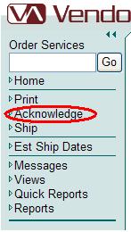

- The screen should now look like the one below. From here click on Review Orders, which is directly above the word “Acknowledge.”

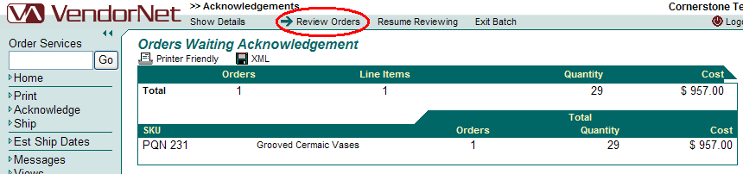

- When your screen updates, check quantities, date, items, etc to be sure you can fulfill the order.
  - If you need changes made, please contact your planner to discuss any changes. If changes are made, they will update to VendorNet within 2 hours of the Planner making the change in our order entry system. Once the changes have been made, you may proceed to Step 6.
  - If you do not need changes made, please proceed to Step 6.

- If you accept the order as displayed, click on “Release Order”, which is far right hand side approximately half way down the screen.

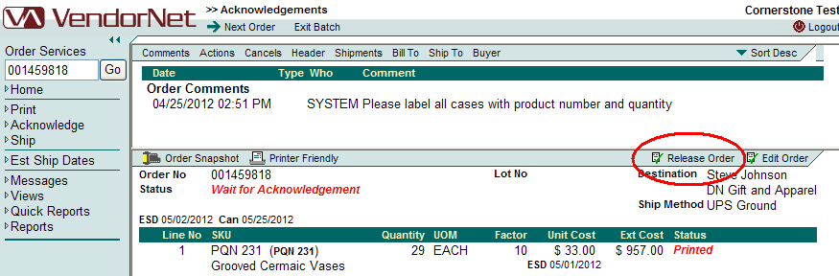

- If you have other orders to view, you will need to repeat steps 5 and 6 until you reach the end of the list. Once you have come to the end of the list, you will see the following screen:
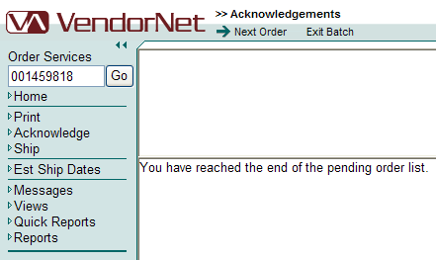

- Once you have reached the above screen, all orders that were released will be available in the “Ship” area to have UCC-128s printed and ASN information collected. **

** If information is changed on the PO after it has been acknowledged, it will revert back to the acknowledge bucket to be processed. You will need to release the order again in order to complete the “Ship” process.

Please contact VTG@cornerstonebrands.com if you require further assistance.

