FAQ’s/Troubleshooting

- My purchase order is all jumbled like the screen below.
  - This is usually caused by the compatibility view settings. If you are working in Internet Explorer, go to Tools-compatibility view setting-and add “ccsginc.com” to the box. If you are a Firefox user and your screen looks similar to the below, please contact VTG to be sure your account is set-up for Firefox.
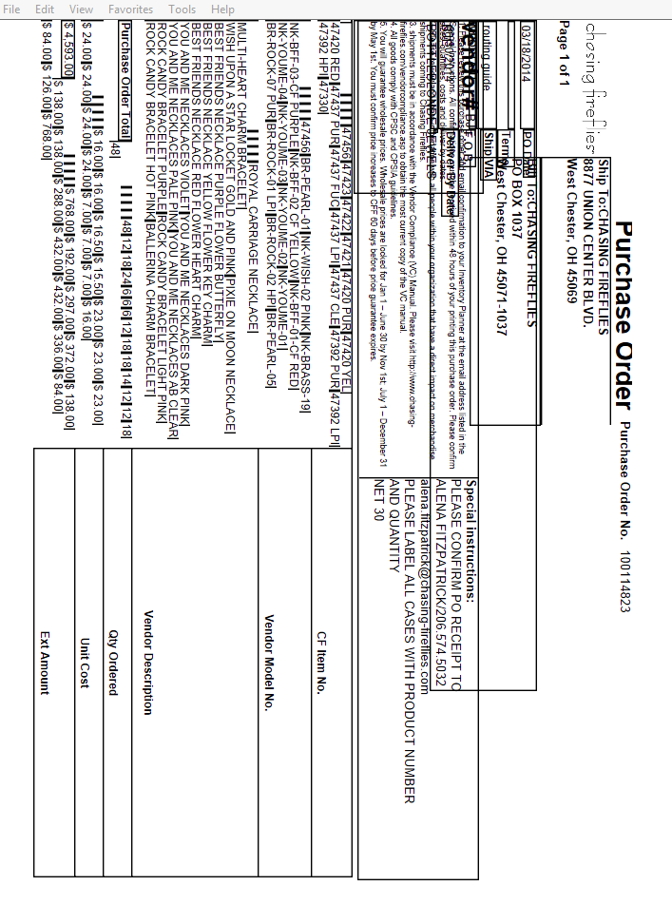

- I am getting a message that I have already printed my labels, but I have not.
  - You will need to follow the “how to reprint case labels” instructions.

- I am getting the below screen.
  - You will need to contact VTG. A setting change needs to be done on our end.

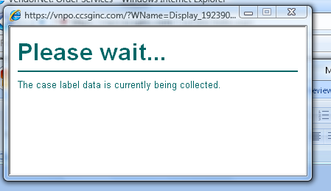
- My labels are printing on top of each other.
  - Please make sure you have adjusted your margins appropriately. All margins should be 0.5, uncheck the bow that says “enable shrink to fit,” put all you headers/footer at empty or blank. If you are printing from a Zebra printer, or label printer, you can also change your paper sixe to “A6” or 4X6 if you have that template. (Firefox users, since you typically do not have the ability to adjust margins, you can shrink you whole page down to anywhere between 95%-85% depending on your printer)
  - If you have made all of the above changes are still having issues, please reach out to VTG.

- I am getting the error “There are no packages in this shipment”
  - This is because a tracking number has not been entered. If you do not have a tracking number, you still need to put some sort of reference number in the field. This can be a PO# or you can put the words UPS or Truck in the box. In order to move on and print your labels, something needs to be put into this box.
- I can’t see the option to “print or reprint” an order
  - This occurs when you do no have the order type specified. Make sure you have “stock PO” or “Dropship” highlighted in the lower left hand side of the screen.

- I want to be able to send the labels to someone.
  - You will need to make the necessary adjustments to the margins (see above). Do a file-print and choose your PDF printer. The file will open up in your PDF program for you to save. If you do not have a PDF printer installed, you can download free ones from the internet.

