How to set up Internet Explorer 7.0 to print out of VendorNet

- Open Internet Explorer
You don’t need to log onto the site before you make the changes.

- From the Menu bar select Tool and then Internet options
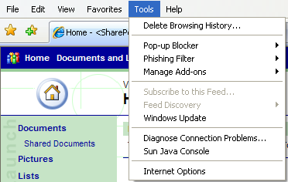

- This will open a window that looks like this

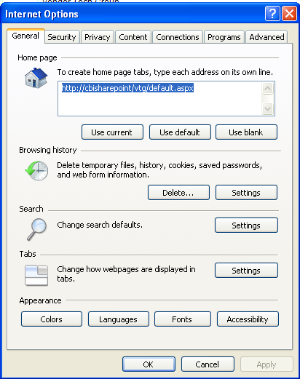

- Select the Security tab
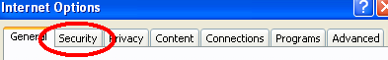
- Which will display this window that looks like this

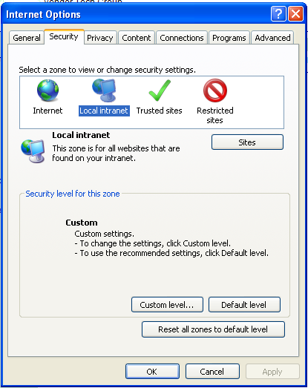
- Now click on the Trusted Sites icon 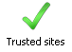
- then click on the button that says sites which will open a window like this 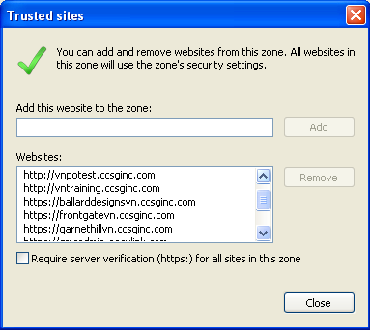

- In the “Add this site to the zone:” area type in your web address and click add. The website you enter should be the website you access to retrieve orders. I.E. If you are a Cinmar vendor, you’ll use https://frontgatevn.ccsginc.com; if you are with Ballard, you’ll use https://ballarddesingsvn.ccsginc.com; and so on.

- Now click Ok which will take you back to here

- Now Click on the button this will bring up this window

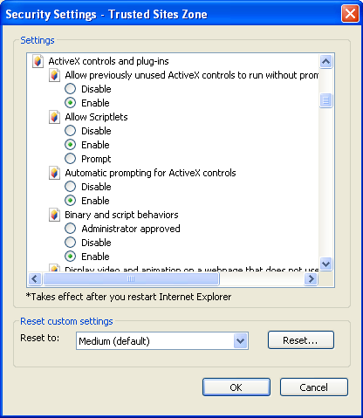

- Find the heading called “ActiveX Controls and Plug-ins”. Change all the setting that have the icon to “Enable”

- Once they are all marked “Enable” click you may get a dialog box that looks like this.

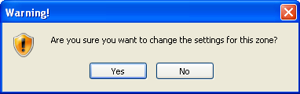

- Click and then Click “ok” at the “Security Settings” window and again at the “Internet Options” window. This will put you back at the Internet Explorer window. You should now be able to login and print.

If this doesn’t work for you please contact:

Vendor Technologies Group
VTG@cornerstonebrands.com

