REPRINTING

All orders within VendorNet can be reprinted as many times as necessary. Orders that are reprinted will contain the word “REPRINT” on the Packing Slip/Purchase Order.

To access the reprinting function click “Print”.
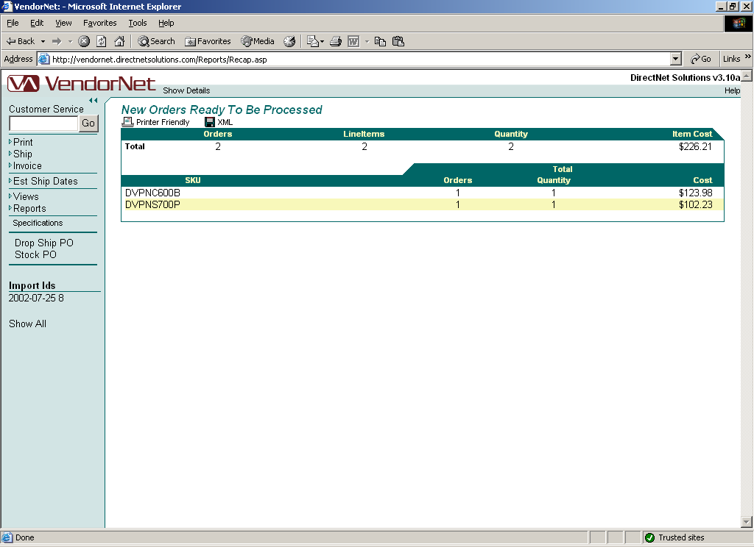
Figure 1.04 – New orders waiting to print

If available, select the type of orders that will be reprinted. Click “Reprint Orders”.
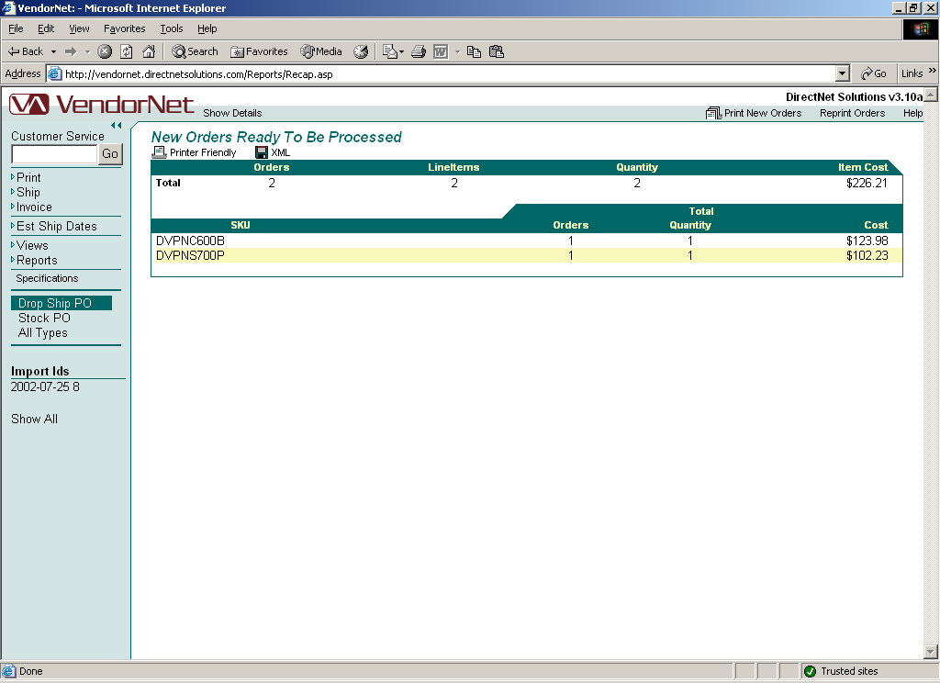
Figure 1.05 – New orders waiting to print; Accessing reprint function

When reprinting orders you must select a Date Range and then click on “Find by Print Batch” or “Find by Import Id”.

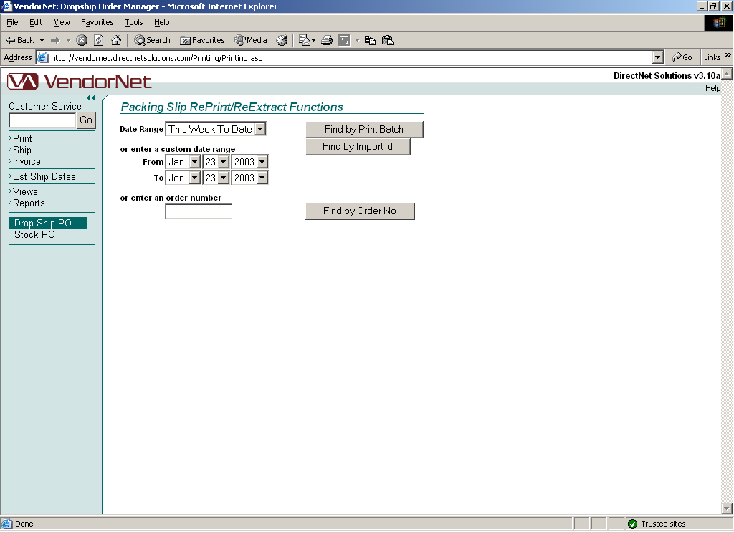
Figure 1.06 – Reprint order; Date selection criteria/functions

Below are the details of the different options available to you when selecting a date range for reprinting orders.

Date Range Drop down menu that allows you to choose from a set of preselected date range or a “Custom” setting that permits you to select your own date range.

Custom Enables you to select your own date range
This Week To Date Includes all days of the current week, beginning Sunday up to the current date
Last Week Includes all days of the last week, beginning Sunday and ending the last Saturday
This Month To Date Includes all days of the current month, beginning the first of the month up to the current date
Last Month Includes all days of the last month
Custom Date Range Used in conjunction with the “Custom” selection from the Date Range drop down
From Beginning date
To Ending date
Enter an Order Number Enter the entire order number

By Print Batch
Returns orders based on the date and time a batch of orders were printed.

By Import ID
Returns orders based on the date and time a batch of orders were imported to VendorNet.
When printing a single order, a date range is not needed.

By Order Number
Used to print an individual order.

Copyright © 2003 DirectNet Solutions, LLC.
All Rights Reserved.
Any technical documentation that is made available by DirectNet Solutions, LLC. is the copyrighted work of DirectNet Solutions, LLC. and is owned by DirectNet Solutions, LLC.
All persons and companies listed in the examples are purely fictitious and any resemblance to existing persons and companies is purely coincidental.
Mention of third party companies and products is for informational purposes only and does not constitute an endorsement.

