asn cREATOR
CCSG, INC.
User’s Guide
And Setup

Table of Contents

Introduction 1
What is ASN Creator? 1
Why Microsoft Excel? 1
What are the system requirements? 1
Periodic Updates 1
Security Setup 2
The Basics 4
Opening ASN Creator 4
Moving Around 5
Switching the Header and Cases Tabs 5
Moving Between Fields 5
Moving in the Case Grid 6
Moving within a Field 7
Moving or Copying Field Contents to another Field 7
Identifying the Parts 9
Header Tab 9
Vendor Number (Mandatory) 9
Vendor Name (Mandatory) 9
Address, City, State, and Zip Fields 9
Contact Name (Mandatory) 9
Contact Phone (Mandatory) 9
User Field 1 and User Field 2 9
PO Number (Mandatory) 10
Shipped Date (Mandatory) 10
Delivery Date 10
Carrier 10
Carrier Pro# (Mandatory) 10
Total Weight (lbs) 10
Total Cases (Mandatory) 10
Total Units (Mandatory) 10
Instructions 11
Check For Errors 11
Print ASN 11
Save ASN 11
Save Vendor Information & Get Vendor Information 11
Version Number 11
Cases Tab 12
Clear Case Information 12
Save ASN 12
Check For Errors 12
Print ASN 12
Export 12
Case and Unit Counts 12
Auto-Populate Cases 13
Beginning Case No. (Mandatory) 13
Base Number or Item Number 13
Suffix #1 or Color 13
Suffix #2 or Size 13
Suffix #3 or 2nd Dim 13
PO Number 13
No. of Cases (Mandatory) 13
Units per Case 13
Calculate Next Available Case After Populate 14
Instructions 15
Case Grid 15
Add Button 15
Del Button 15
Case Number (Mandatory) 15
Base Number or Item Number (Mandatory) 15
Suffix #1 or Color 16
Suffix #2 or Size 16
Suffix #3 or 2nd Dim 16
Qty (Mandatory) 16
PO Number 16
Version Number 16
Helpful Hints 17
Validation Processes 17
Validation Check List 17
Entering Multi-SKU Cases 17
Identifying Case Grid Errors 18
Sending the ASN 18

Introduction

What is ASN Creator?
ASN Creator was developed using Microsoft Excel as an alternative to using EDI or VendorNet. Although not as powerful as EDI or VendorNet, this spreadsheet is an effective tool for creating and communicating ASN’s to CCSG, Inc.

Why Microsoft Excel?
Microsoft Excel was chosen because of its widespread use in the business community. Rather than provide a program that must be installed and updated, ASN Creator can simply be opened in Excel.

What are the system requirements?
ASN Creator can be run on any Windows based PC (Pentium 4 or higher is recommended) installed with Microsoft Excel 97 or higher. If you are using an a computer from Apple (i.e. MAC) contact vendor compliance.

Periodic Updates
Occasionally, updates will be made to ASN Creator. It is important to check for updates on the web site each time a new ASN is needed.
Security Setup
Before using ASN Creator, security settings in Excel need to be configured. As with all of the examples, these were created using Excel 2003. Your version may vary slightly. For additional information on setting security, consult the help files in Excel. If you are using Excel 97, this setup may not be necessary.
ASN Creator uses programming (macros) to help create ASN’s. It will not run correctly without first being configured successfully to run macros.
Step 1: Open Excel.
Step 2: From the menu bar, select Tools and then Options.
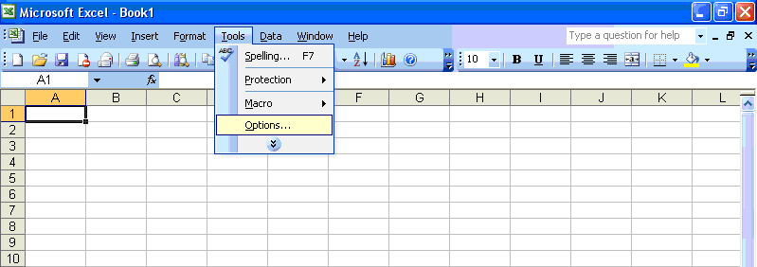
Step 3: From the Options window, click the Security Tab. Next, Click the Macro Security button.
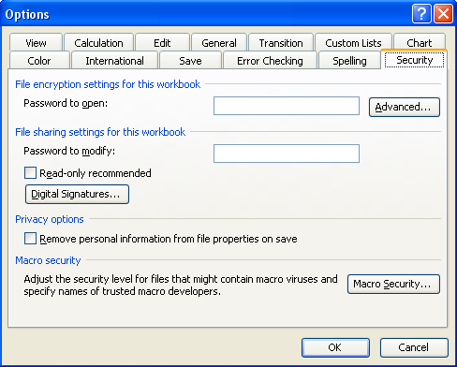
Step 4: In the Security window, select either Medium (Recommended) or Low. Then, click the OK button.
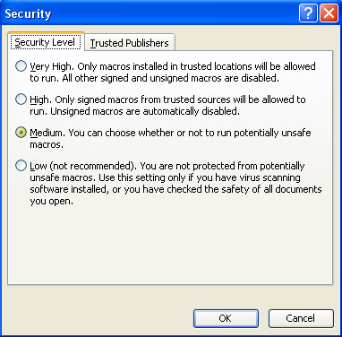

Step 5: If Medium Security was selected in Step 4, each time ASN Creator is opened a Security Warning window will appear. Click the Enable Macros button.
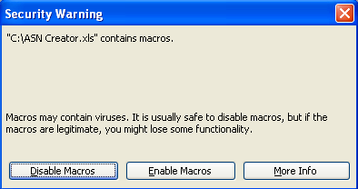
The Basics

Opening ASN Creator
If you want to view another spreadsheet while using ASN Creator, you will need to open another instance of Excel by choosing it from the Start menu.
Open ASN Creator by either double-clicking on the icon or by opening Excel and choosing ASN Creator from the File\Open menu option. Be sure to choose Enable Macros if prompted. Go to the Security Setup section for further explanation.
After opening ASN Creator, the following window should appear:
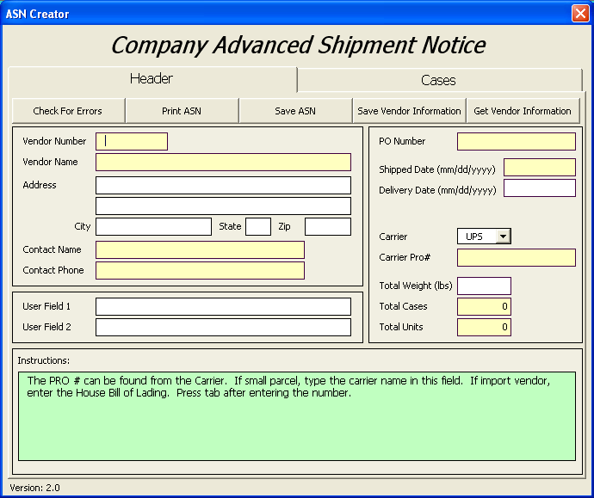
If the window on the previous page does not open and the following appears, ASN Creator will not function. You must close ASN Creator, check your security settings, and Enable Macros if prompted. Refer to the Security Setup section for more information.
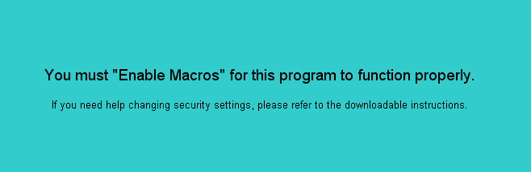

Moving Around

Switching the Header and Cases Tabs
There are two main sections to ASN Creator: Header and Cases. The Header is used to enter vendor information, purchase order, and shipment information. The Cases tab is used for entering case information. To move between the two, simply click on the appropriate tab. Changing tabs can be done any time while an ASN is being entered.
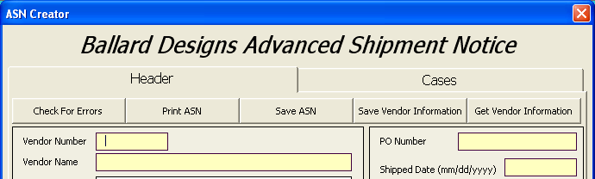

Moving Between Fields
Moving from one field to another (e.g. Moving from Vendor Number to Vendor Name) can be accomplished by doing one of the following:
- Use the mouse and to point and click in field.
- Use the Tab key to move from one field or button to the next. If the shift key is held down while pressing the Tab key, movement will be in the opposite direction.
- Use the Enter key to move from one field to the next. Be careful using the Enter key. If you have a button selected, such as the Check For Errors button, and press Enter, it is just like clicking the button with the mouse.

Moving in the Case Grid
The Case Grid is located on the Cases tab.
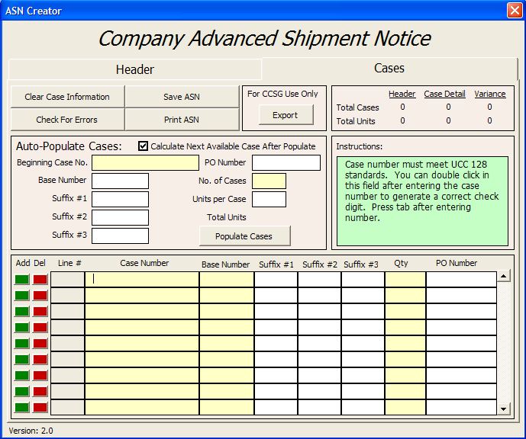
The following explains the different methods for moving within the Case Grid:
- Use the mouse to point and click in the field.
- Use the Tab or Enter key to move from on field to the next. The Shift key can be held down with the Tab key for movement in the opposite direction.
- The arrow keys can be used to move up, down, left or right.
- The Page Up and Page Down keys will move the fields up or down nine rows at a time.
- Holding down the Ctrl (Control) key and the pressing one of the arrow keys will move to the extreme top, bottom, left or right of the grid.
- Holding down the Ctrl (Control) key and pressing the Home or End key will move to the extreme top-left or bottom-right of the grid, respectively.
- The scrollbar, located to the right of grid, can be used to move in multiple ways by using the mouse:
- Click on the arrows at the top or bottom of the scrollbar to move the grid one row up or down.
- Click on any part of the scroll bar, other than the arrows, above or below the slider (the square/rectangle that moves up and down) to cause the grid to page up or down.
- Click on the slider, hold the mouse button, and move the slider up or down to move multiple rows at a time in the grid.
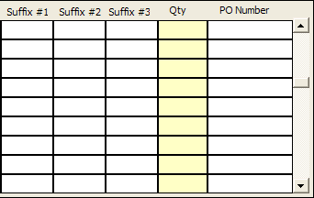

Moving within a Field
Not only can movement be done from field to field, but it can also be done within a field:
- The left and right arrow keys will move the cursor (the blinking line) from one character to another.
Note: If the cursor is not visible and the text is highlighted all one color, click the left or right arrow, and it will appear.
- The Home key will move the cursor to the beginning of the text, and the End will move the cursor to the end of the text.

Moving or Copying Field Contents to another Field
By highlighting the contents of a field, the contents can be moved or copied to other fields.
Step 1: Highlight the contents of a field by doing one of the following:
- Use Tab or Enter to move to the field that is to be copied. The contents of the field will automatically be highlighted. Notice the Vendor Number highlighted in blue below:
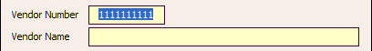
- Use the mouse arrow to click in the left-most area of the field (circled below).
- Use the mouse to click in the field, leaving the mouse button pressed, and moving left or right to highlight the portion of the field to be copied.
- Use the mouse to click in the field, and then hold down the Shift key while pressing the left or right arrow key to highlight the portion of the field to be copied.
Step 2: Once the text to be copied has been highlighted, press and hold the Ctrl (Control) key and then press the “C” key to copy or the “X” key to cut/move. When the “X” key is pressed the highlighted text will disappear.
Step 3: Move to the field where the text is to be placed.
Step 4: Press and hold the Ctrl (Control) key and then press the “V” key to paste/put the text in the field.
Note: Repeat Steps 3 and 4 to copy the same text to other fields.
Identifying the Parts

Header Tab
Note: Mandatory fields are highlighted in yellow in ASN Creator.
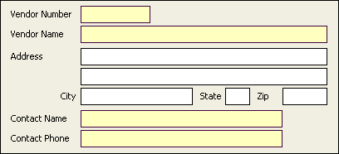

Vendor Number (Mandatory)
Vendor Number can be found on the Purchase Order (P.O.), or from your Inventory Planner.

Vendor Name (Mandatory)
This is the name of the company listed on the PO that is shipping the merchandise.

Address, City, State, and Zip Fields
Enter the address of the company that is shipping the merchandise. If you need to enter a country code, use the second address field.

Contact Name (Mandatory)
Enter the name of the individual in the organization that can be contacted for support if needed.

Contact Phone (Mandatory)
This is the phone number for the contact name.

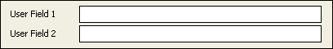

User Field 1 and User Field 2
Enter any internal or miscellaneous information.
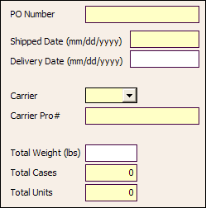

PO Number (Mandatory)
This can be found on the top of the Purchase Order. The PO Number must match exactly. The number entered will automatically be prefixed with the correct number of zeros after leaving the field. If the ASN is for more than one PO, enter the primary PO here. This will be the default PO. Other PO numbers can be entered in the Case Grid for individual cases.

Shipped Date (Mandatory)
The Shipped Date must be entered mm/dd/yyyy, and is the day tendered to the Carrier.

Delivery Date
The Delivery Date must be entered mm/dd/yyyy, and is the day CCSG is expected to receive the shipment.

Carrier
Select a preferred abbreviated carrier/shipment method from the drop down box by clicking the down arrow and clicking on the appropriate option, or type the abbreviation for the carrier if it is not listed. Upon entering the field, typing the first letters of the abbreviation will automatically populate the closest match.

Carrier Pro# (Mandatory)
This number can be obtained from the carrier. If small parcel, type the carrier name in this field. If import vendor, enter the House Bill of Lading.

Total Weight (lbs)
Enter the total weight of the product being shipped.

Total Cases (Mandatory)
Enter the total number of cases on the shipment. When the ASN is complete and ready to be saved, this number must match the total number of cases entered in the Case Grid. The maximum number of cases that can be entered is 9,999.

Total Units (Mandatory)
Enter the total number of units on the shipment. When the ASN is complete and ready to be saved, this number must match the total number of units entered in the Case Grid. The maximum number of units that can be entered is 999,999.
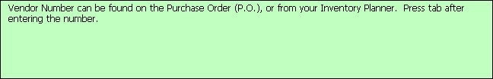

Instructions
Each time a field is selected, the instructions for that field will be displayed. Notice they are similar to the instructions in this section of the manual.

Check For Errors
Clicking this button will check both the Header and Cases tabs for any errors. If any errors are found, a window will display explaining the errors. This button is the same as the Check For Errors button on the Cases tab.

Print ASN
This button will print a report to the default printer. It contains both the Header and Case information. This button is the same as the Print ASN button on the Cases tab.

Save ASN
Before attempting to save, the ASN will be checked for errors. This is the same validation as the Check For Errors button. If there are errors found, a window will display stating that the ASN was not saved, as well as, listing the errors found. If no errors are found, the Save As window will be displayed so that a name and a location can be chosen. This button is the same as the Save ASN button on the Cases tab.

Save Vendor Information & Get Vendor Information
By clicking this button, the Vendor Number, Vendor Name, Address, Contact Name, and Contact Phone will be saved to a file on the user’s PC. This information can then be populated in future ASN’s by clicking the Get Vendor Information button.

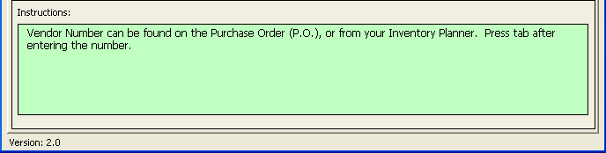

Version Number
The ASN Creator version number is located on the bottom left of Header and Cases tabs. This is useful for identifying that the most recent version is being used by comparing it to the one on the web site.

Cases Tab

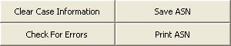

Clear Case Information
This button deletes all cases entered in the Case Grid. A prompt will display verifying that the cases should be deleted.

Save ASN
Before attempting to save, the ASN will be checked for errors. This is the same validation as the Check For Errors button. If there are errors found, a window will display stating that the ASN was not saved, as well as, listing the errors found. If no errors are found, the Save As window will be displayed so that a name and a location can be chosen. This button is the same as the Save ASN button on the Header tab.

Check For Errors
Clicking this button will check both the Header and Cases tabs for any errors. If any errors are found, a window will display explaining the errors. This button is the same as the Check For Errors button on the Header tab.

Print ASN
This button will print a report to the default printer. It contains both the Header and Case information. This button is the same as the Print ASN button on the Header tab.

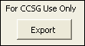

Export
This button is reserved for CCSG use only and is password protected.

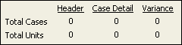

Case and Unit Counts
The Header column is the Total Cases and Total Units entered on the Header tab. The Case Detail column is the total number of cases and units entered in the Case Grid. The Variance column is the difference between the other two columns. The variance for both Total Cases and Total Units must be zero before the ASN can be saved.
Auto-Populate Cases
This section is a convenient way to populate multiple cases into Case Grid quickly. This feature is not required to be used. Cases can be entered into the Case Grid manually. In order to use this section a valid UCC-128 case number must be entered and the number of cases to be populated. The other information may be filled in if desired. The case numbers will be generated sequentially with the proper check digit when the Populate Cases button is clicked. Changes can be made to the case information in the Case Grid after the cases have been populated.
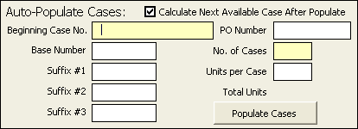

Beginning Case No. (Mandatory)
This is the first case to be generated and must meet UCC-128 standards. You can double click in this field after entering 19 of the 20 numbers to generate a correct check digit if you don’t have it. This check digit must match the check digit on your UCC-128 labels or they must be reprinted.

Base Number or Item Number
This field may display differently depending on your version. This should match the information on the PO. If the PO has 1234 BLUE 36 UNH, then enter 1234 here.

Suffix #1 or Color
This field may display differently depending on your version. This should match the information on the PO. If the PO has 1234 BLUE 36 UNH, then enter BLUE here.

Suffix #2 or Size
This field may display differently depending on your version. This should match the information on the PO. If the PO has 1234 BLUE 36 UNH, then enter 36 here.

Suffix #3 or 2nd Dim
This field may display differently depending on your version. This should match the information on the PO. If the PO has 1234 BLUE 36 UNH, then enter UNH here.

PO Number
If you wish to enter a PO Number different than the one on the header, enter it here. If nothing is entered, the PO Number on the header will be assumed. PO Number can be found on the top of the PO and must match exactly. The number entered will automatically be prefixed with the correct number of zeros after leaving the field.

No. of Cases (Mandatory)
This is the number of cases to be populated in the case grid for the particular item number and PO entered above.

Units per Case
This is the number of units in each case.

Calculate Next Available Case After Populate
If this box is checked, the next available case number will be calculated and entered into the Beginning Case No. after populating cases. If you leave this box unchecked, the original case number entered will remain.

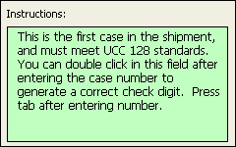

Instructions
Each time a field is selected, the instructions for that field will be displayed. Notice they are similar to the instructions in this section of the manual.

Case Grid
The Case Grid is used to review, add, change and delete cases from an ASN and works similarly to a spreadsheet.
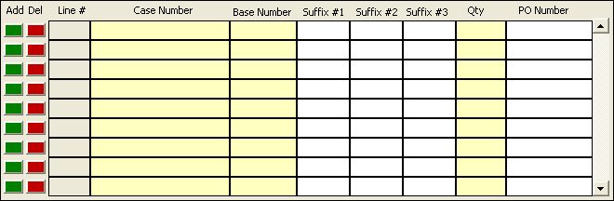

Add Button
Click the add button beside the line where a new line is to be inserted. The case on that line and the ones below it will be shifted down and the line number adjusted accordingly.

Del Button
The delete button will delete the line next to the button. There will be a window displayed to confirm the deletion when the button is clicked. All cases below the case being deleted will be shifted up and the line numbers adjusted accordingly.

Case Number (Mandatory)
The case number must meet UCC 128 standards. You can double click in this field after entering 19 of the 20 numbers to generate a correct check digit if you don’t have it. This check digit must match the check digit on your UCC-128 label or it must be reprinted.

Base Number or Item Number (Mandatory)
This field may display differently depending on your version. This should match the information on the PO. If the PO has 1234 BLUE 36 UNH, then enter 1234 here.

Suffix #1 or Color
This field may display differently depending on your version. This should match the information on the PO. If the PO has 1234 BLUE 36 UNH, then enter BLUE here.

Suffix #2 or Size
This field may display differently depending on your version. This should match the information on the PO. If the PO has 1234 BLUE 36 UNH, then enter 36 here.

Suffix #3 or 2nd Dim
This field may display differently depending on your version. This should match the information on the PO. If the PO has 1234 BLUE 36 UNH, then enter UNH here.

Qty (Mandatory)
Quantity is the number of units in the case.

PO Number
If you wish to enter a PO Number different than the one on the header, enter it here. If nothing is entered, the PO Number on the header will be assumed. PO Number can be found on the top of the PO and must match exactly. The number entered will automatically be prefixed with the correct number of zeros after leaving the field.

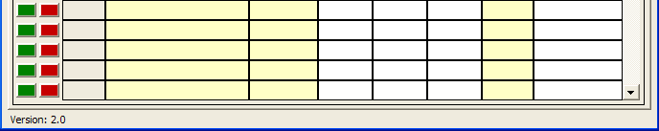

Version Number
The ASN Creator version number is located on the bottom left of Header and Cases tabs. This is useful for identifying that the most recent version is being used by comparing it to the one on the web site.
Helpful Hints
Validation Processes
ASN Creator is only able to validate field lengths, data formats, case check digits, and whether a field is required. It can not know if a PO number is correct, whether a valid SKU has been entered, if the vendor number is correct, etc. When entering the information, double check it to be sure it is correct. It is very important that the ASN be accurate in order to save both time and money.

Validation Check List
- Is the vendor number & vendor name correct?
- Is the contact name & number accurate?
- Are the PO numbers the correct for the SKUs being sent?
- Is the shipped date accurate?
- Was the carrier & pro number entered correctly?
- Are the case numbers being sent accurate? Case numbers can not be used from previous shipments.
- Does the SKU information match the PO?
If there are any questions regarding any of these, please contact the inventory planner.

Entering Multi-SKU Cases
To enter a case that contains multiple SKUs, simply enter the SKUs with the same case numbers on multiple lines in the Case Grid. The SKU must be different on each line. See the example below. The lines can be entered one after another but can be separated in the grid.
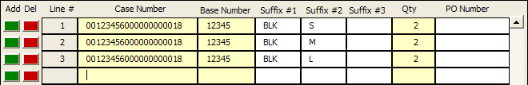

The case count will only count this case once.
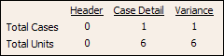
Identifying Case Grid Errors
When checking the ASN for errors, ASN Creator will change the color of the fields to red that have an error. To see the description of an error for a specific field, move the mouse cursor over the field. A message will appear identifying the error.

Sending the ASN
Once the ASN has been completed, save ASN Creator using a name that identifies the ASN and email the saved file per the inventory planners instructions.

