August 11, 2004

Dear New Garnet Hill Vendor,

Welcome to the Garnet Hill family! At Garnet Hill, much of our success derives from the strong relationship we have developed with our vendors over the years. Together, we and our vendors provide customers with beautifully designed products of the highest quality and value, delivered with award winning customer service.

The Garnet Hill’s Vendor Manual is an outline of the company’s operating principles. It will provide you with an overview of the Garnet Hill business philosophy, detailing how we work together with vendors to develop, buy and ensure the quality of our products. Our objective is to work with you in a spirit of cooperation and partnership to help us achieve our mutual goals.

In order to develop a sound business partnership, it is critical that our vendors understand our business procedures and requirements.

- Quality Assurance Requirements
- Shipping Procedures and Documentation Requirements

Important requirements are provided in the attached guidelines that will expedite shipping and avoid costly delays and mishandling issues. All information in the Vendor Operations Manual should be considered confidential and proprietary to Garnet Hill, Inc. We urge you to carefully read this manual in its entirety and share its contents with the appropriate individuals within your organization. You will be contacted shortly by our Vendor Relations Coordinator, to ensure you are comfortable with this communication and also to welcome you to our family of suppliers. In the interim, should you have any questions, please don’t hesitate to contact the vendor relations coordinator at (603)823-5545 Ext. 1712 or vendorhelp@garnethill.com. This person is here to help you.

We look forward to a mutually rewarding business relationship with you and your staff. This manual is intended to facilitate our relationship. We invite your questions or comments regarding our policies and procedures as you review the manual, or at anytime in the future.

Respectfully,

Russ Gaitskill
President

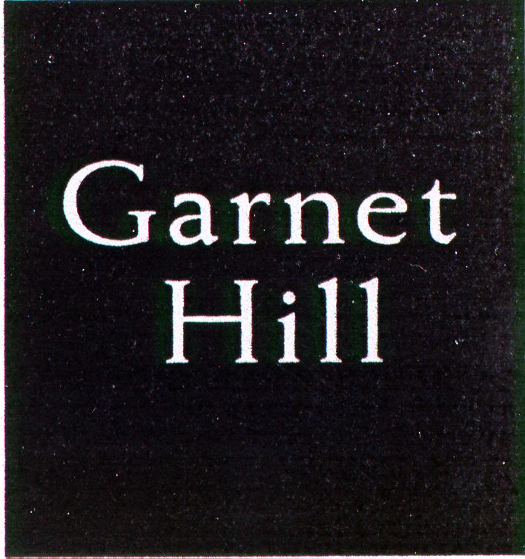

Garnet Hill Vendor Compliance Manual

Revision 4.1

TABLE OF CONTENTS

GARNET HILL CODE OF CONDUCT Page 4

VENDOR SHIPMENT ‘CHECKLIST’ Page 5

ITEM LABELING Page 6

Quality Planning Page 8

Top of Production Pages 8 -9

PERFORMANCE STANDARDS Pages 10 - 12

INDIVIDUAL ITEM PACKAGING REQUIREMENTS Pages 13 – 14

Package Testing: Hard Goods Page 15

CASE SIZE REQUIREMENTS Page 16

EXTERNAL CASE LABELING (UCC-128 Labels) Pages 17 - 18

UCC-128 CASE LABEL RECOMMENDED Source Page 19

UCC-128 CASE LABEL PLACEMENT Pages 20 - 21

CASE SEALING AND PALLETIZING A SHIPMENT Page 22

RUG COMPLIANCE Pages 23 - 24

IMPORT REQUIREMENTS Page 25

BILL OF LADING Page 26

ADVANCE SHIP NOTICE (ASN) OPTION & SPECIFICS Pages 27 - 28

PACKING SLIP Page 29

CHARGE BACKS Page 30

VENDOR MANUAL ACKNOWLEDGMENT PAGE Page 31

Garnet Hill Code of Conduct

Garnet Hill will work only with suppliers who meet stringent employment social accountability standards and rigorous environmental standards. We require suppliers to meet the following standards and our agents to monitor that all suppliers are in compliance with these standards, thank you for your help.

Code of Conduct:

- Child Labor: No person under the age of 16 (or older if specified by local law) may be employed in the production of merchandise for Garnet Hill.
- Forced Labor: There shall not be any use of forced labor, prison labor, indentured labor or conscript labor used in manufacture of Garnet Hill merchandise.
- Harassment or Abuse: Every employee shall be treated with respect and dignity. No employee shall be subjected to any physical, sexual, psychological or verbal harassment or abuse, or corporal punishment.
- Nondiscrimination: Workers shall be employed based on their abilities, rather then their personal characteristics or beliefs.
- Freedom of Association: Workers shall have the freedom to organize freely for the purpose of collective bargaining.
- Health and Safety: All work places are required to be safe and healthy working environments and to be in compliance with all local safety and environmental laws.
- Fair Wages: Employees must be paid in accordance with the local and/or national laws or regulations as a minimum standard.
- Working Hours: Overtime hours shall be compensated at such premium rate as is legally required by national or local laws.

Garnet Hill Vendor Shipment Checklist

- Vendor receives purchase order from Garnet Hill -Both Bulk and TOP for new styles

- Vendor confirms purchase order receipt, dates and quantities with Garnet Hill.

- Individual items are packaged as required. See pages 13-14

- Individual items each have an item label with Garnet Hill Sku on the packaging. See page 6.

- TOP samples are sent for approval. All bulk shipments are held until approval is given. See pages 8-9.

- Master cartons are packed with only ONE Sku per case.

- Master cartons have a UCC-128 case label affixed to narrow, leading end of case. See pages 20-21

- The UCC-128 case label corresponds correctly to its case contents. See pages

- UCC-128 label numbers are used to fill out the electronic ASN (Advanced Ship Notice) form.

- The ASN is 100% accurate and error free, matching GH information from PO.

- The packing list is completed and affixed to the leading case in a shipment.

- The correct shipment carrier has been called using the most current routing guide.

- The ASN is emailed to both email addresses required the day a shipment leaves.

- RUG SHIPMENTS are palletized as required from the vendor manual.

- Any questions have been addressed and completely resolved.

- Shipment is received 100% compliant with Garnet Hill’s needs.

Item Labeling

All individual item packaging must contain an item label with Garnet Hill specific Sku information exactly as it appears on a Garnet Hill purchase order. The label must have the following information:

- Garnet Hill Item #
- Color – Garnet Hill Code
- Size – Garnet Hill Code

Labels must use a universal font at least 12 point. The label must be large enough to be seen clearly and accommodate the font; an address size label (1” x 2 5/8) works well.

Example of an item label:

4523 GREN TWFL
Location of Item Labels on Packaging:

Polybags – Place the item label on the front of the packaging, in the lower, left corner.

Boxes – Place the item label on the face of the box in the lower left corner.

Quality Planning

Garnet Hill is committed to providing superior quality merchandise and service to its customers. We recognize that superior merchandise quality is achieved through unrelenting attention to detail, from product conception to customer purchase and beyond. This philosophy mandates the development of close relationships with our vendors, systematic monitoring of incoming products and the evaluation of customer response to product quality.

We believe that the burden of producing quality products rests with the vendor. We also believe that it is our responsibility to support our vendors by clearly defining our expectations, requirements and standards. We build vendor partnerships on a foundation of openness and trust.

All products are expected to meet the minimum performance, safety and testing standards that are detailed in the enclosed document “Testing and Performance Standards.”

The Top of Production Review described below is an important part of assuring the quality of our product and enabling vendors to be successful in meeting all expectations.

Garnet Hill inspects all incoming bulk shipments using a statistical sampling plan. Our inspection guidelines support our efforts to provide customers with the best products available by ensuring that we receive goods as specified from our vendors. Our critical inspection is based on high quality expectations. Products are measured to ensure conformance to the approved sizing specifications within established tolerances and then checked for defects and conformity to all specifications.

When a shipment fails an incoming inspection, Garnet Hill may choose to conduct 100% inspection for which the vendor will be charged labor costs at $50 per work hour. If a significant quality problem is discovered, Garnet Hill may decide to return the product to the vendor without completing 100% inspection.

Garnet Hill requires its vendors to have an effective quality system in place to monitor and assure quality performance. This includes testing and inspection of materials used, inspection of work-in-progress and a final quality audit of finished products. The audit of finished products should be conducted independently of production management, incorporating statistical sample methods. This final quality audit will verify that products meet all Garnet Hill specifications, including those for construction details, choice of materials, color and sizing. Shipped lots must be free of defects, dirt, or damage. Merchandise is to be packaged according to Garnet Hill requirements, with all labeling applied as specified.

We believe that by working together to produce superior quality merchandise we will ensure our mutual success.

TOP OF PRODUCTION: Quality and Packaging Samples

The TOP review is part of Garnet Hill’s Quality Assurance Program. This process requires vendors to send samples from the production run to Garnet Hill in Franconia, NH for review and approval before the bulk shipment is sent to the distribution center in Ohio.

During the review, products are measured/washed/checked against buyer specifications and compared to photo samples and catalog photos. Packaging of hard goods is tested according to our packaging requirements.

The goal of the review is to verify that the product is as purchased, is first quality, and is packaged adequately. The review also gives us the opportunity to check package labeling and identify any product issues that can be corrected while the goods are still in the vendor’s facility. This saves the vendor time and expense in making corrections.

Receiving these samples ahead of the shipment is essential to the efficient receipt of the shipment at our distribution center. If samples are not received and reviewed in Franconia ahead of the shipment, receipt of the bulk shipment and payment of goods will be delayed. For this reason, vendors will be charged a penalty for not sending TOP or shipping bulk shipments before TOP approval.

TOP OF PRODUCTION- Procedure

1. TOP Sample Requirement
Garnet Hill requires that samples of each new item be sent to Garnet Hill in Franconia, NH for approval before the bulk shipment is released from a vendor’s facility. Vendors will receive a special purchase order specifying the items to be sent.

2. Actual Production Merchandise and Packaging
The TOP samples are to be first off the production line and packaged and labeled as the bulk production will be packaged and labeled. If production will be individually boxed, it must be boxed as bulk production will be boxed. Approval samples will not be requested on reorder shipments unless the product has changed in any way: i.e. sizing, fabric, or make from the original.

3. Samples Arrive in Advance of Shipment
TOP samples must arrive in Franconia, NH in advance of the specified ship date for the bulk shipment, so approvals do not delay shipping. The TOP Purchase Order will specify the ship date required. This date will be 15-30 days in advance of the bulk ship date. We require a minimum of 5 working days to review and approve TOP samples.

4. Shipment Held for Approval
Do not release the bulk shipment of goods until Garnet Hill has received and approved these samples. Garnet Hill quality staff will call or fax approval when the goods are approved to ship. If you cannot hold a shipment pending approval, call Garnet Hill to discuss this shipment.

5. Payment for Samples
Garnet Hill will pay for these samples if they are first quality and are packaged and labeled as finished product. We prefer that the cost of these samples be included in the cost of the goods. If you require payment, send an invoice for these items. Samples that are not first quality or are mutilated, will not be paid for.

6. Transit Method
Address these samples to: Garnet Hill
TOP OF PRODUCTION
231 Main Street
Franconia, NH 03580. USA

Send samples the best way to facilitate approval. Use expedited shipping only if necessary to meet the approval time line. Notify Garnet Hill with information about when the samples were sent and by what carrier. Call: TOP Staff: (603)-823-5545

7. Sample Request
The following samples will be requested: (Samples requested may vary from this list)
- Apparel: One of each size, include all colors.
- Shoes: One of each size, include all colors.
- Accessories, jewelry: Two samples of each style (boxed as production will be boxed)
- Bedding Flat Sheet, Fitted Sheet, Cases, Sham, and Duvet: include all colors.
- Blankets, Coverlets, Comforters, Quilts, Curtains, Bedskirts, Throws, Pillows:
One of each size, include all colors
- Towels: One of each size, include all colors
- Lamps/Gifts/Rugs/Other: Two of each style (boxed as production will be boxed)

Testing and Performance Standards

Testing and Performance Standards: Apparel and Textiles
Property | Standard | Test Method
Tensile Strength: Woven | 25 lb./in. | ASTM D 5034
Burst Strength: Knits | 40 PSI | ASTM D 3786
Tear Strength: Woven | 3.0, (Flannel 2.0) | ASTM D 1424
Seam Slippage | less than 1/4" @ 15 lbs. | ASTM D 434-95
Seam Strength | 15 lb. | ASTM D 1683
Colorfastness to Crocking (Rubbing) |  | AATCC 8 - 1996
Dry | 4.0 | **
Wet | 3.0 | **
Colorfastness to Washing - Home Laundering |  | AATCC 61-1996
Shade Change | 4.0
Staining | 3.0 ***
Colorfastness to Dry-cleaning |  | AATCC 132-1998
Shade change | 4.0 | **
Staining | 3.0* | **
Colorfastness to Perspiration |  | AATCC 15-1997
Shade change | 4.0 | **
Staining | 3.0 * | **
Colorfastness to Non-Chlorine Bleach | 4.0 | AATCC 172-1997
Dimensional Change in home laundering | Acceptable after wash sizing or As specified | AATCC 135/150-2000
Colorfastness to Light - 20 hours |  | AATCC 16-1998
Curtains | 3-4 | **
Garments | 4.0 | **
Home Bedding Products | 3.0 | **
* If appearance is unacceptable at 3, fabric will be rejected ** Light Box Viewing Conditions: D65/U30
*** If lower than 3.5 must be labeled: Wash Separately
Skewness change in fabric and garment twist in home laundering |  | AATCC 179-1996
Garments - woven | 1% after wash
Garments - knits | 2% after wash
Home bedding products - knits | 5% after wash
Home bedding products - woven | 3% after wash
Fabric Weight - ounces per square yard | + or -5% from purchase weight | ASTM D 3887
Pilling resistance - 30 min Random Tumble Pilling Tester Method |  | ASTM D 3512 After 3 launderings
Apparel | 4
Napped Goods | 3
Flammability
Apparel (Test Suspect fabrics: Napped and lightweight fabrics: < 3.0 oz/sqyd) | Class 1 | 16 CFR 1610
Mattresses and Mattress Pads | Pass | 16 CFR 1632 , and CA TB 106
Children's sleepwear: Tight Fitting/ Flame Retardant | Comply | 16 CFR 1610, 1615, 1616
Small Rugs Less than 24 sq ft and less than 6 ft in any one dimension | Pass or be labeled | 16 CFR 1631 (FF2- 70) Label to read: " Flammable, fails US Dept of Commerce Standard FF 2-70, Should not be used near source of ignition.
Carpets Greater than 6 ft in one dimension or greater than 24 sq ft. | Pass | 16 CFR 1630 (16 CFR FF1-70)
Sleeping Bags | Pass | ASTM 1955-99
Blankets | Class 1 | ASTM D 4151
Purity of specialty animal fiber | Pass | AATCC 20A - 2000
Sterility of Stuffing Materials: Pillows, battings, mattresses, sleeping bags, furniture | Comply and be labeled with required Law Label | State Regs: i.e. PA - A 249
Drawstrings: children's clothing sizes 0-16 | No drawstrings at neck. Waist: sewn at midpoint, restrict total length to req. | ASTM F1816
Trims, Notions, Zippers, Buttons used for children
Lead Content | <0.06% by dry weight | 16 CFR 1303
Small Parts (If attached small pieces do not pass the Small Parts test, the attachment method must pass Use and Abuse testing, i.e. zipperpulls, buttons, snaps). | Cannot fit in test cylinder | 16 CFR 1501
Use and abuse/ test attachment method | Pass 15 lb test | 16 CFR 1500.53
Testing and Performance Standards: | Hard Goods
Property | Standard | Test Method
Art Materials: toxicity | Pass | ASTM D 4236
Bouncy Seats | Pass | ASTM F2167-01
Bunk Beds | pass | ASTM - F 1427
Candles
No Lead content in wick (metal wicks) | < 0.06% by weight (600 ppm total lead) | 16 CFR 1500.17
Consumer Burn Warning Candles should always be placed away from flammable material, on a fireproof receptacle, and out of children's reach. NEVER LEAVE A BURNING CANDLE UNATTENDED. | Label required on product | ASTM F2058-00
Safe burning charactertiscs (candle and candleholders) | Flame height <3" base to tip.no secondary ignition,no tip over, no breakage of container | ASTM PS 59-02
Ceramics and Glassware | Pass CA Prop 65 stds | ASTM C 738, CA 65
Lead Content | Flatware:0.226ppm, Small hollowware: 0.1 ppm, Large hollowware: 0.1 ppm, Cups, Mugs: 0.1 ppm, Pitchers: 0.1 ppm
Cadmium Content | Flatware:0.1ppm, Small hollowware: 0.1 ppm, Large hollowware: 0.08 ppm
Cribs | pass | ASTM F 1169-03, 1822-97
Floor Cushions and Bean Bags | Styrofoam beads must be enclosed in separate liner. Seam strength must perform to tension test @ 15 lbs. ASTM F963 | 16 CFR 1500-1512
Furniture Tip Over ( Children's items > 30" height) | Pass | ASTM F 2057
Furniture targeted for children | Pass | ASTM F 963
Furniture: Flammability
Furniture: Cigarette Resistance | Pass | CA TB 117
Furniture: Small Flame Resistance | Pass | CA TB 117
High Chairs | Pass | ASTM F404-99a
Lighting and Lamps | UL Approved
Painted Products | < 0.06% by dry weight | 16 CFR 1303
Personal Care Products | Pass | 21 CFR 1,2,20,250,700,701,720 740 FDA
Toys: Any product determined to have possible "children's play value" | Comply | ASTM F963 Test for: Small parts, toxicity, pinching, entrapment, edges, points, projections, folding mechanisms, holes, clearances, stability, confined spaces, stuffing, beanbag filling, use and abuse, tip over, flammability….
Stated Age Recommendations | Comply | ASTM F 963
If not intended for a child under 3 yrs - must have a warning label on product | Comply | ASTM F 963
Lead content in paints and surface coatings | < 0.06% by dry weight | 16 CFR 1303
Sterility of Stuffing Materials | Comply and be labeled with required Law Label | State Regs: i.e. PA - A 249
Toy Chests | Comply | ASTM F834-84(1999)

Individual Item Packaging Requirements

All merchandise must be individually packaged and labeled. Packaging must be designed to meet the needs of the rigorous handling necessary for the mail order process. This includes: shipping to our Distribution Center, Handling within our Distribution Center, Shipping to our customer, and then as needed, being returned by our customer to our Distribution Center. These are harsher shipping and handling conditions than what is encountered in retail or more traditional distribution methods. Packaging of breakables and larger “ship alone” items must pass the “Package Testing Requirements” that follow on page 15.

Item Packaging:

Apparel
We require that all apparel be packaged in folded, flat-pack form in polybags that are taped or heat-sealed. Merchandise must be folded to fit snug in the polybag so that it does not “puddle” and end up crumpled and wrinkled. Some items may require folding around a cardboard stiffener or tissue.
Merchandise must be folded neatly (pressed if necessary to remove wrinkles) to a size of pleasing proportions. The size of the finished package must fit appropriately in the carton size specified (see Shipping Carton Requirements).
Merchandise may be sent on hangers, only if the Merchandising Department gives prior approval. Merchandise on hangers must be covered with garment bags that are closed at the bottom or hang at least 6” below the product.
Adult swimsuits must have hygienic liners applied before shipping to Garnet Hill.

Shoes
Package in shoebox with labeling on one end of the box Pack master cases in solid case packs whenever possible, not doing so may result in charge backs.

Bedding
Sheets: Package in polybags or shrink-wrap
Blankets, Quilts: Package in vinyl zip storage bags
Pillows: Package in polybags

Rugs
Most rugs must be rolled and packaged in plastic that is closed at both ends. Small rugs (2’x3’ or smaller) may be packaged flat in plastic.

Jewelry
Jewelry must be individually boxed, in a jewelry box with cotton and the box enclosed in a plastic bag that is taped or heat-sealed.

Soap, brushes
These items must be individually bagged or boxed appropriately to protect the item and ready for Garnet Hill to ship to our customer.

Ceramics, Glass items
Ceramic items or anything in a glass or breakable container must be boxed and packed with protective packing material. Do not use Styrofoam beads as packing material. Mark case appropriately when fragile merchandise is enclosed. See page 15.

Liquid Products
All liquid products must be in containers with lids that have a leak proof seal. These products must be boxed, protected, and packed ready for us to reship to our customer. Do not use Styrofoam beads as packing material. See package testing page 15.

Games
Games must be individually packaged and protected to secure all individual parts and protected during shipping. Do not use Styrofoam beads as packing material.

Furniture
Furniture that is shipped to the Garnet Hill Distribution Center must be individually boxed, packed with protective packing and ready for Garnet Hill to ship to our customer. See package testing page 15.

Lamps
Lamps must be individually boxed, packed with protective packing and ready for Garnet Hill to ship to our customer. See package testing page 15.

Polybags
All polybags must be a clear poly with a minimum thickness of 1.00 mil. Bags must have vent holes (they can be purchased pre-punched). The polybags must completely enclose products and be heat sealed, self sealed or securely taped. Envelope bags or those with a non-adhesive flap must be taped closed. Use bags that are BHT free. It is your responsibility to ask this of your bag supplier. Bags containing BHT (Butylayted Hydroxyloluene) can cause yellowing of the product. Should this occur you will be charged-back all applicable charges.
PACKAGE TESTING REQUIREMENTS: HARD GOODS

All packaging for hard goods items must be package tested before shipping to insure that our customers will receive merchandise undamaged. All packaging must have passing test results to ASTM, ISO, or ISTA standards from a certified lab OR be tested using the following guidelines. All packages will be tested in-house at Garnet Hill using the guidelines (1) and (2) below.

General packaging guidelines:
1) An item needs to “float” or be suspended in the middle of the carton.
2) There must be no movement or rattling when the carton is shaken.
3) The outer cardboard must be sturdy enough to fully protect the item when it is dropped as described.
TEST METHOD:
- All items with weight less than 150lbs and girth less than 165 inches will be dropped from a height of 30 inches. The item will be dropped a total of 14 times using the drop techniques below. (Girth =Longest side + (2 X (next longest side + smallest side))

  - Item is dropped on the manufactured corner bottom, the direct opposite top corner and the three seams leading away from those corners.
  - Item is dropped on the top, bottom and all four sides.

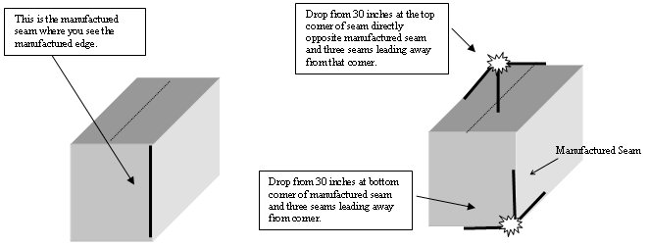

- All items with weight more than 150lbs and girth more than 165 inches will be dropped from a height of 24 inches. The item will be dropped a total of 10 times using the drop techniques below.

- Item is dropped on the manufactured corner bottom and the three seams leading away from those corners.
- Item is dropped on the top, bottom and all four sides.

Drop from 24 inches at bottom corner from manufactured edge and three seams leading away from corners.

Case Size Requirements

Master packing should be used whenever possible to maximize shipment costs to Garnet Hill. This means that individual items are packed inside a larger master case before being shipped by a vendor.

To keep within conveyable sizes for master packs, cartons must stay below the size listed in the picture below:

Maximum Height Maximum Length
26” 40”
1
*1) UCC-128 Case Label Maximum Width 26”

Master cases must never exceed a maximum weight of 50 lbs. If there is only a single item per case due to the large size or weight of the merchandise, then the product is considered a ‘ship separate’ item as long as the case sizes stay in the ranges above. If any case is outside the size range listed above, it is no longer conveyable and should be treated as a ‘non-conveyable’ or ‘ship separate’ item.

Each individual item in a master case needs an item label. See page 6.

Damage to our automated conveyor systems can be caused if cartons are banded, strapped, or have string securing them. Please do not use any sort of carton banding, charge backs will occur if banding is used.

CASES MUST CONTAIN ONLY ONE SKU (COLOR, SIZE) WHENEVER POSSIBLE and multiple purchase orders should never be mixed in cases.

External Case Labeling (UCC-128 Labels)

- UCC-128 bar coded case labels are required on each case in a shipment.
- These UCC labels can be purchased from our suggested supplier (ADI) at (937) 704-9644, Jerry Gribler is our contact at this number. This is the recommended method of obtaining UCC-128 labels.
- The UCC labels can also be created through Vendor Net, once a vendor is set-up and has passed testing.
- Vendors producing their own UCC labels must have their labels approved prior to using them in a shipment. Please fax samples to (603)823-8406, Attn: Vendor Relations Coordinator

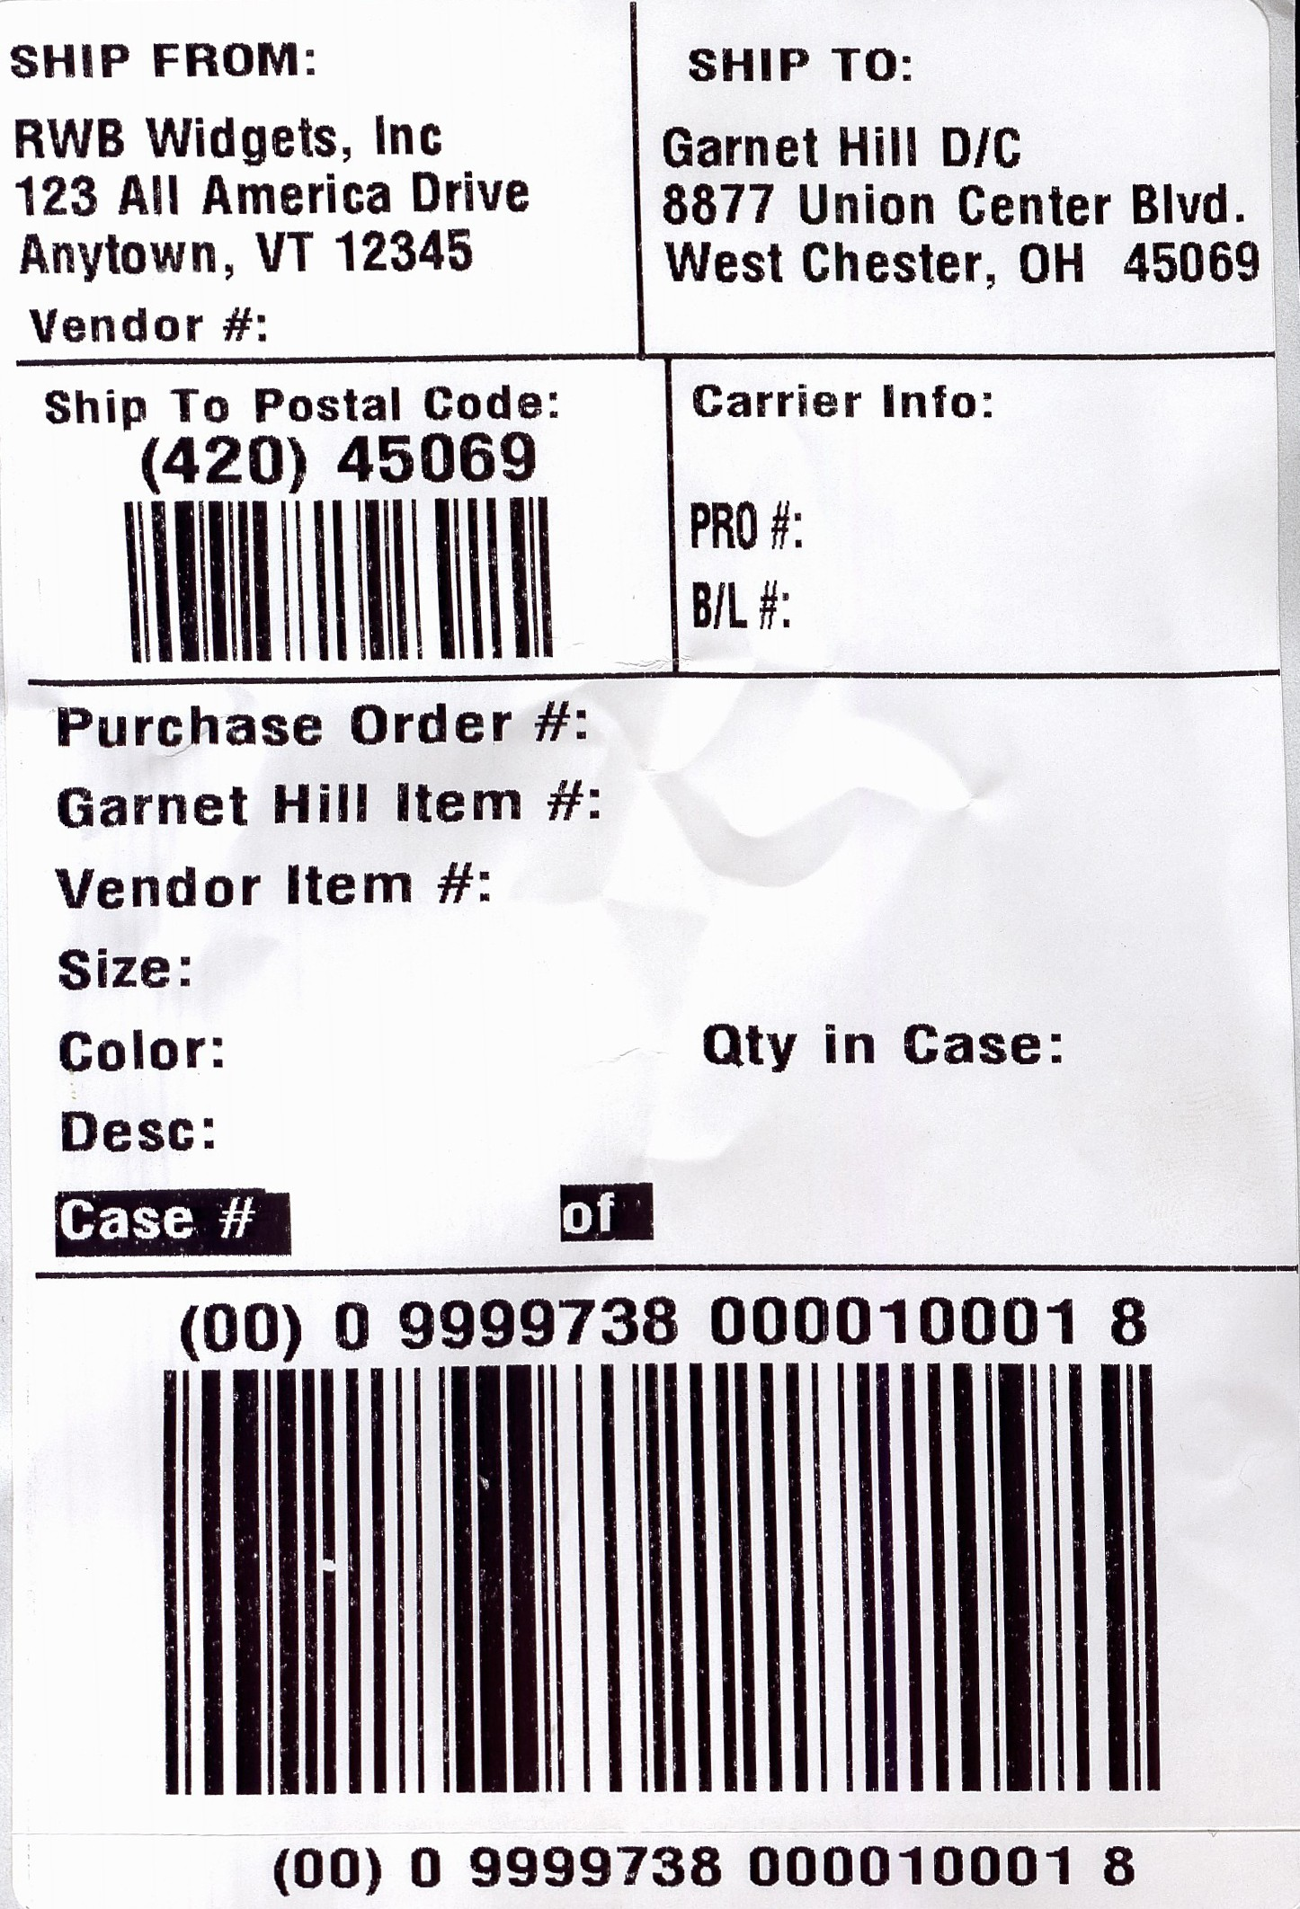
Sample UCC-128 Label:

UCC-128 Shipping Case Label Data Requirements: | General Information:
Vendor Shipping Information (address) | UCC-128 Case Label must appear on every case
“Ship-To” Information (from PO) | Recommended label dimensions:
Bill of Lading (BOL) # | English: 6”(H) x 4”(W)
Purchase Order (PO) # | Metric: 15 cm(H) x 10cm(W)
Garnet Hill Item # | Type must be at least 3/16” (or 10 pt)
Vendor Item # | Attach ucc-128 label to lower left corner on smallest end of each case, NO OTHER BAR CODED LABELS SHOUD BE PLACED ON THE CASE
Item Description (Size, Qty, and Color) EXACT ABBREVIATIONS that appears on a purchase order. | PRO #’s may be requested in advance from issuing Shipping Company (You may leave blank if unavailable)
Quantity per Case | Low-reflective tape, if tape is used on the label
UCC 128 Symbology (Case Identification Bar Code)
Case Count (i.e. “01 of 05”)

UCC-128 Case Label - Specific Characteristics
Explanation of Symbology

(00) 0 0012345 555555555 8
1
2
3
- Vendor’s UCC Number (or UPC preceded by a zero)
- Unique carton identification number (nine digits)
- Check digit (mathematical formula)
*The Uniform Code Council has approved a standard format for UCC-128 case labels. Vendors can find this information by visiting their website: www.uc-council.org

UCC-128 Case Labels must have this bar code Symbology:

- The bar code must meet the following specifications:
-UCC Code 128, subset ‘C’
-20 Digits – encoded, numeric
-Minimum narrow element: .02”
-Wide element: 1.0”
-Minimum bar code height: 1.0”
-Maximum pattern length: 3.12”
-Overall pattern length: 3.52” (including ‘quiet’ zones)

B) There must be a bar code quality program in place that ensures ANSI A or B print quality (ANSI X#.182). Smudge proof labeling/ink and low reflective tape (if tape is used to apply the label) is required.

Garnet Hill UCC-128 Recommended Source

ADI

Adaptive Data Interchange is not affiliated with Garnet Hill in any way. Many of Garnet Hill vendors use this company to create their UCC-128 case labels. They are a reliable, inexpensive source that guarantees 100% accuracy of UCC-128 labels.

When contacting ADI, simply let them know that you are a Garnet Hill vendor and they will lead you quickly through the process of ordering UCC labels. ADI knows the correct format to apply to labels for Garnet Hill vendors.

Jerry Gribler
(937) 704-9644
Fax: (937) 704-9814
Email: jgribler@adi-barcode.com

Jerry Gribler at ADI will quote you their most current pricing, which is very inexpensive and generally more cost effective then creating the labels internally.
UCC-128 Case Label Placement

Case Label Placement for Conveyable and Non-Conveyable Cartons

How to Determine Conveyable vs. Non-Conveyable Products

Max Height Max Length
26” 40” Max Width
1
1) UCC-128 Label
26”

Conveyable Cases – This diagram shows the maximum dimensions for conveyable cases. This is the largest case that can ride freely on our automated conveyor system.

Non-Conveyable Cases – If a case is larger then any of the dimensions listed above then the case is non-conveyable.

Conveyable Labeling Guidelines

- The UCC-128 Case Label must be placed on the smallest end of a case.
- Disregard the ‘height’ of the box and find the smallest side; place the label on this side.
- The UCC-128 label should be placed in the lower, left corner on this side of the case.
- The label should be placed about one inch from the bottom and left side of the case.
- If the box is smaller at its smallest end than the label, please place the bar code in the required location as mentioned above and fold the top of the label over the top of the case.
- Case labels must have a valid bar code that is scannable. Our warehouse’s scanner is located in the lower left hand area of the conveyor system. Please follow the guidelines above very carefully.

Non-Conveyable UCC Labeling

Label placement on non-conveyable cartons must allow for quick and efficient hand scanning. All UCC-128 case labels must be placed, facing out, and only one label per case please.

Labels must be placed on the smallest end of a case in the lower, left hand corner. This enables us to maximize space in our warehouse. Please see below for a correctly labeled pallet of non-conveyable cases.

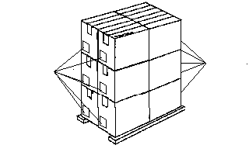
UCC-128 Case Labels
UCC-128 Case Labels, Placed facing outwards.
Non-Conveyable with Arrow Directions

Safe handling of merchandise is top priority at our warehouse and storage facility. Non-conveyable cases with arrow directions (‘this side up’, etc.) should have labels placed in a manner that corresponds to these directions.

The UCC-128 case label must be placed on the lower left hand corner of the case, corresponding to the arrow being in correct vertical position.

UCC-128 Case Label
CASE SEALING/PALLETIZING

Taping and Sealing Cases

- 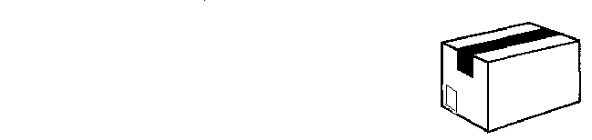Due to the large number of cases received at the Distribution Center, standardized case sealing simplifies inventory and quality inspections. Taping must not hide any required case markings or labels.
Garnet Hill requests that cardboard inserts be placed in the top and bottom of each case to protect merchandise when carton is opened.
Sealing Technique for the Standard Case:

Apply single strip of tape to seal case with a minimum 3’ overlap on each end. Please be aware the 3” overlap is a requirement by Garnet Hill’s Insurance Company. Be careful not to cover any labels.

- To prevent damage to our material handling equipment, do not secure individual cases with straps, bands, staples, or string (except Ship Alone Items). Strapping of pallets is acceptable.

Palletizing
- The required pallet size is 48” long x 40” wide (1.22m long x 1m wide).
- Maximum height of pallet 65” (1.65 meters) including cases and pallet.
- Cartons on the pallet must not overhang pallet length or width
- Use Four-way pallets.
- A pallet label with the following information, must be on all 4 sides of EACH pallet:
- Ship to: Garnet Hill
- Ship From: Vendor Name
- Vendor Address
- Garnet Hill PO #
- PRO #
- Place cases on pallet so all case labels face outward as shown below:
- 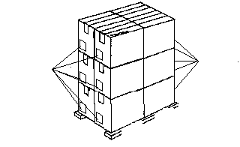Cases of the same PO should be numbered “xx of xx” starting with “01 of xx”.
Pallet labels
On all 4 sides

Case labels

Case labels

RUG PACKING AND LABELING

All rugs shipped to the warehouse must meet the following qualifications:

- One Sku (color, size) per pallet whenever possible.
- Each individual rug should be placed in durable plastic shipping bag with an item label. (See section on item labeling for details.) One rug per plastic bag please.
- Pallet should be accommodating to the length of the rugs; no part of the rug should touch the ground.

- Small rugs should be individually wrapped in plastic, and then placed inside a master gaylord case.

- Rugs must be stretch wrapped or banded to a pallet to prevent shifting during transport.

- Each pallet must have a UCC-128 case label placed on the outside of the pallet’s wrapping, in clear view. Please see the section on UCC-128 case labels for details.

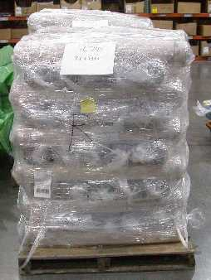
Example of a stretch wrapped skid secured to a standard sized pallet.

Pallet label placed on the outside, in the bottom left hand corner.

Palletizing Rugs

Palletization with or without use of gaylord boxes is required of rug shipments. Failure to comply with this requirement is a charge back issue.

Large volumes of rugs are difficult to move due to their awkward size and shape. The following guidelines should be closely followed to avoid unnecessary damage, ONE Sku per pallet whenever possible.

- If possible, transport rugs in gaylord boxes. (see example of a gaylord box below) This offers the best protection and makes it easy to unload and move the rugs.

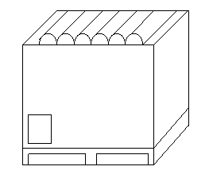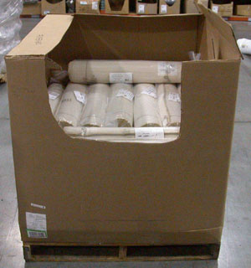
Pallet
UCC-128 Case Label in lower, left corner of gaylord box.

Vendor Import Requirements

The U.S. Customs Service requires entries pay all duties and taxed applicable to the U.S. government at the time of importation. Duties are assessed when an importing carrier arrives at the port of entry. U.S. Customs requires specific documentation to secure the release of merchandise. This documentation must be provided within five days of a carrier arriving at a port of entry. The required documents to provide U.S. Customs are:

        - Original Bill of Lading (BOL), carrier’s certificate or airway bill properly consigned.
        - Signed commercial invoice and packing list.
        - Detailed description of merchandise in English.
        - Declare the value of merchandise in U.S. dollars.
        - Other costs of merchandise (freight, insurance, etc.)
        - The quantity for each Sku in a shipment.
        - The total weight in kilograms.
        - The country of origin of an item.
        - Textile information (fiber content as stated on invoice), also state if knit, knapped, ornamented, etc.

Additional Labeling Requirements for Import Vendors

In addition to all other Garnet Hill labeling requirements stated in this manual, U.S. Customs will require:

- Case Labeling: Country of Origin must be clearly marked on each case in a shipment. This can be a supplemental label or directly on a case.
- Item Labeling: Each imported item must be clearly marked with the Country of Origin and fiber content (if applicable) and must appear in English. Textiles will have this information on sewn in labels and hard good on supplemental, secure labels.

Additional Requirements for Import Vendors:

- Packing Slips must be ON and IN the lead case for every purchase order being shipped. (Cases should be numbered xx of xx, starting with 01 of xx for each P.O., 1 being the lead case)
- Bill of Lading (BOL) and PRO# are supplied by the import vendor’s freight forwarder.
- The carrier for an import vendor IS their freight forwarder.
- Cases must meet the following dimensions:
-Minimum case weight is 2lbs. (.9kg)
-Maximum case weight is 50lbs. (22.7kg)
Bill of Lading

The Bill of Lading (BOL) must have carton count and purchase order numbers present. If multiple P.O.’s are shipped on one B.O.L., then the total cartons across all ASN’s must match the total cartons on the B.O.L. (The BOL consolidates carton count.) Remember that there should be only one purchase order per ASN submitted though.

Routing Guide & Transportation

All shipments must follow the most current routing guide instructions. Please view the routing guide each time you need to send a shipment by visiting www.ccsginc.com and clicking on the Garnet Hill – Vendor Partnership specific link.

Please contact the Garnet Hill Vendor Relations Coordinator for the username and password you will need to access this website. The Vendor Relations Coordinator can be contacted via email at vendorhelp@garnethill.com

Advance Ship Notice (ASN)

- All purchase orders require an Advance Ship Notice to be sent out the same day as the shipment. The ASN should be sent via EDI or using the electronic form available through our vendor partnership website, www.ccsginc.com
- FAXED ASN’S ARE NOT ACCEPTABLE. The fax machine has been turned off at our warehouse and they can not receive ASN’s from vendors.

ASN Creator Form (Found on website)

- Vendors should visit our website, www.ccsginc.com to obtain a username and password to access the Garnet Hill vendor partnership website. The ASN form should be downloaded to your desktop each time a vendor needs to send an ASN.
- The PRO# field on the ASN can be left blank by simply typing N/A into the space.
- Once the ASN is completed and correct, please save the file and email as an attachment to two locations; asn-gh@ccsginc.com and asn@garnethill.com

EDI

- Vendors currently having passed EDI testing with Garnet Hill may continue to utilize this method of transmitting and receiving data.
- Please contact our EDI Coordinator, Chris Snodgrass, at csnodgra@ccsginc.com for further information on EDI testing and set-up. He may also be reached by phone at (513)603-1186.
- If you wish to begin EDI testing, please contact our Vendor Relations Coordinator or our EDI Coordinator at the above email address.

Vendor Net

- Vendor Net is a web based application that enables a user to receive purchase orders, print out UCC-128 case labels, send an ASN and invoice an order over the internet. There is no cost to a vendor to take advantage of this easy to use program.
- Vendors using Vendor Net may continue to purchase UCC-128 case labels from an outside source as special printers and paper are required for this task.
- If you wish to be considered for Vendor Net set-up, please contact our Garnet Hill Vendor Relations Coordinator at vendorhelp@garnethill.com

ASN (Advance Ship Notice) Specifics

- Garnet Hill requires a detailed ASN with complete UCC-128 case level information for every shipment sent to our Ohio warehouse. The full twenty digit UCC label number should be transferred to the appropriate line on the ASN. No two case numbers should ever be the same, each is always unique! The Garnet Hill Sku information should also be filled into each line appropriately matching the case contents and case number as should the quantity in case and case number sequence. The Sku information is contained on a purchase order and includes the Garnet Hill item number, color and size abbreviations. Abbreviations should be transferred to the ASN exactly as they appear on a purchase order.
- Cases should always contain only ONE Sku where quantities allow.
- Only ONE purchase order should be listed on an ASN, if you are consolidating multiple purchase orders into one shipment, please list all purchase orders on the B.O.L. (Bill of Lading) but remember to send a single ASN for each P.O.
- A unique B.O.L. is required for each truck shipped. If multiple trucks are shipping merchandise, then each must have its own B.O.L. Please remember that a B.O.L. may contain multiple purchase orders, however; if a shipment is so large more then one truck is needed to pick-up, then the shipment must have a separate B.O.L. for each truck.
- ASN’s must be 100% complete and accurate. There is a charge for incorrect ASN’s due to the amount of time it takes to receive a shipment against an incorrect (or missing) ASN.
- Please be sure to make a note on an ASN if a purchase order is not shipping complete. The ASN should read that the shipment is a ‘partial’ shipment.
ASN’s should never be transmitted for Top of Production (T.O.P.) orders. These orders are shipped to our administrative offices in Franconia, NH and do not travel to the warehouse in Ohio.

Packing Slip

Sample Packing Slip (vendors may use other formats): Please include inside your lead case in a purchase order as well as attached to the outside of the lead case.

VENDOR NAME
Street Address
City, State, Zip Code
Phone Number

Fax Number

PACKING SLIP

BILL TO: SHIP TO:
Garnet Hill Garnet Hill Distribution Center
231 Main Street 8877 Union Centre Blvd
Franconia, NH 03580 West Chester, Ohio 45069

CARRIER USED: PRO #: SHIP DATE:

PURCHASE ORDER #:

 | CASE NUMBER  (XX OF XX) | G.H. ITEM DESCRIPTION | VENDOR ITEM | GH ITEM#, COLOR, SIZE | CASE QTY

TOTAL UNITS TOTAL CASES TOTAL PALLETS TOTAL WEIGHT

Charge Backs for Non-Compliance

As a partner of Garnet Hill we ask that vendors appreciate the importance of our compliance requirements. It is necessary that you comply with all of our policies and standards. Non-compliance results in delays and additional work in our Distribution Center, therefore non-compliance with any of the required guidelines will result in a charge back to the vendor.

Charge backs are $250 per violation per purchase order. These charges are audited carefully at our distribution center:
- Failure to send TOP samples or receive TOP approval before shipping to the Distribution Center
- ASN
- UCC-128 Case Label
- Item Labels
- Rug Compliance

Notification of a charge back issue is delivered via email to a list of email addresses provided by a vendor to the Vendor Relations Coordinator. This may be changed by the vendor at anytime, please contact our Vendor Relations Coordinator to change your email address. The Garnet Hill accounting department is notified of the charge simultaneously and the charge is deducted from a vendor’s next invoice payment.

In the case of ‘Letter of Credit’ or ‘Wire” payment vendors, please send a check in U.S. dollars for the entire amount of the charge back to the attention of our Vendor Relations Coordinator within five days of receiving the charge.

Late purchase orders will also incur charges at a percentage of the total cost, for example:

5% of the cost for a shipment 1 week late
8% for a shipment 2 weeks late
15% of the cost for a shipment three weeks late

Transportation Violation Charge Backs:

1) Freight shipment must be shipped collect, terms prepaid.
- Garnet Hill requires shipments being paid by Garnet Hill to be shipped on a freight collect basis. Merchandise invoices with freight charges added with are paid minus the freight charges. Invoices submitted for freight charges will be returned unpaid.
2) If UPS is used per Routing Guide, shipments must be terms collect.
- Please use the UPS account number on our routing guide.
3) Un-Authorized Carriers:
- If Garnet Hill is paying for any portion of a shipment’s freight, then the carrier selected must be determined by our Routing Guide. Carrier is determined based on total weight and origination of a shipment. Wrong carrier selection will result in full payment by the vendor for freight.
4) Merchandise transported to wrong location.
- Shipments must be transported to the location specified on your purchase order. Failing to ship to the correct location will result in:
A) All freight charges will be the vendor’s responsibility
B) Any transfer freight fees or holding fees will be the vendor’s responsibility.
C) An expense for time and effort will be assessed to the vendor

Acknowledgment of Vendor Compliance Manual Revision 4.1

Vendor Name: ___________________________________

Garnet Hill Code of Conduct
All suppliers must comply with these standards.

Top of Production (T.O.P)
TOP samples must be submitted for all initial purchase orders with new items.
Approval of TOP samples must be acknowledged by Garnet Hill prior to a bulk shipment being sent by a vendor.

Advance Ship Notification (ASN)
Every purchase order shipped to Garnet Hill requires an ASN. Faxed ASN’s are not accepted. An electronic version can be found on our website or EDI may be used.
ASN’s should be 100% accurate and match the purchase order and shipment.

UCC-128 Case Labels
Each case in a shipment must have a UCC label.
UCC-128 labels must be affixed to the leading end of a case in the required location.
UCC-128 labels must be 100% accurate and reflect the case contents with SKU.

Case Contents
Individual cases must contain only ONE Garnet Hill SKU wherever quantities allow.
Each piece of merchandise must have an item label with Garnet Hill SKU.

Case Size Requirements
Case size should not exceed 26”(L)x26”(W)x40”(H) in inches.
Ship Alone items do not need to conform to these requirements.

Carrier Selection
The most current Garnet Hill routing guide must be used to select a carrier.
A carrier is selected based on shipment location and weight and is collect billed.
No unauthorized shipments will be accepted.
Vendors must consolidate same day shipments onto one B.O.L.
Carton count and PO numbers must be present on the B.O.L. and match PO’s and ASN’s.

It is acknowledged by this signature that the information contained in the Garnet Hill Vendor Compliance Manual has been reviewed and is accepted. Purchase orders will be shipped compliant to Garnet Hill, Inc. as outlined in this manual. Expenses incurred as a result of orders being sent non-compliant will be the sole responsibility of the vendor.

Please acknowledge receipt and understanding of this manual by completing this form and returning a copy via fax or email to the address below.

________________________________________________________________

Company Name/Address/Phone No./Email Company Representative/Title

____________________________ ______________________________

____________________________ ______________________________

____________________________ (Please Print) __________________

____________________________ Signature_____________________

____________________________ Date_________________________

